ASSIGNMENT 1

Draw a Home Network Topology

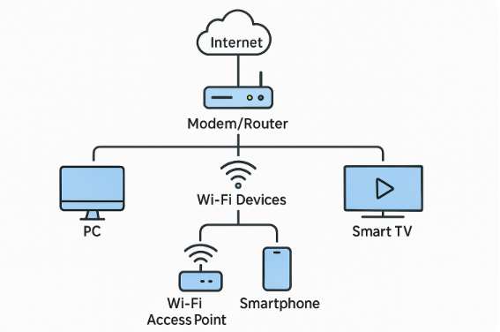

**Internet**

* This is the big web where all websites, apps, and online services live.
* Your **Internet Service Provider (ISP)** gives you access to it.
* It connects your home to the rest of the world.
* Think of it like the road to the rest of the digital world.

**Modem/Router Combo**

* Most homes have one device that acts as both a **modem** and a **router**.

**Modem:**

* Translates signals from your ISP (like a translator between your house and the internet).
* Think of it like a gatekeeper that connects your home to the internet.

**Router:**

* Distributes the internet inside your house.
* Sends the signal out **via cables (wired)** and **Wi-Fi (wireless)**.
* Assigns local IP addresses to your devices so they can talk to each other.

**PC (Wired Connection)**

* Connected to the router via an **Ethernet cable**.
* Very stable and fast — great for working, gaming, or downloading big files.
* Doesn’t suffer from Wi-Fi signal loss.

**Wi-Fi Devices (Smartphones, Laptops, Tablets, etc.)**

* These devices connect **wirelessly** to your router.
* Convenient because you can move around with them.
* But the farther you are from the router, the weaker the signal may get.

**Smart TV**

* Connected by Wi-Fi or cable.
* Let’s you stream Netflix, YouTube, and other apps.
* Can also be part of your smart home (control lights, voice commands, etc.)

**Wi-Fi Access Point (Optional but Helpful)**

* Boosts or extends Wi-Fi signal in larger homes.
* Great for places where Wi-Fi from the main router is weak (like upstairs or basement).
* It talks to the main router and passes on the internet to far-away rooms.

